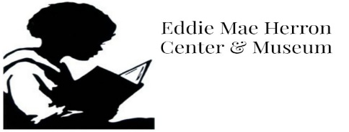
Eddie Mae Herron Museum/Center

2nd Annual Juneteenth
3 on 3 Basketball Tournament
Saturday, June 17th, 2016
Riverfront Park, Pocahontas, AR (location may vary)
Play will begin at 9 a.m.
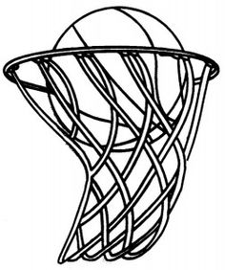
$30 per team, donations accepted
Lunch & drinks provided
- 3 players per team, plus 1 substitute
- Double Elimination
- 4 teams each division
- Games played to 20, no 3’s pointers
- Scheduled times will be announced at later date
****All teams need to be submitted by June 14th***
Divisions
5th-7th grade boys & girls (8 teams total)
8th-11th grades boys & girls (8 teams total)
Age 18 & up (4 teams total)
**Space is limited; divisions may vary due to participation**

Eddie Mae Herron Center Juneteenth 3 on 3 Basketball Tournament
Division_______________________________ Gender__________________
Team Name: ___________________________ Team Captain_______________
Participant Waiver
The Eddie Mae Herron Museum Center, board members and volunteers are not responsible for injuries or personal property damage as result of your participation in activity. I agree to abide by the rules & regulations, and good sportsmanship is expected from players and parents.
Parent Signature (17 & under) required.
Player Grade/Age Phone Parent Signature
1.
2.
3.
4.
***Forms can be picked up at EMHC or contact Micheal Johnson @ 870-219-5703 or Tasha Meeks 870-378-4391 for further information.

